**Date: 19.03.2025**

To,  
**Jaya Kumari**Hyderabad

**Subject: Internship Offer**

Dear Jaya,

With reference to your interview with us dated 18th March 2025, we are pleased to offer you the Internship of “**Wordpress Developer**” During this internship, you are going to be reporting to the CEO.

It will be an unpaid internship program for the period of 2 months starting from **20-03-2025 to 20-05-2025** to help you advance your knowledge and abilities under the supervision of professionals, with the following terms & conditions:-

* Your work schedule isfrom Monday-Saturday from 9:30 am to 6:30 pm. However, the nature of work may require some variation and extension of days or time.
* Each intern is required to put in at least eight hours of work per day. In case of late entry he/she is required to stay back & complete 8 hours of work excluding break.
* You are allowed to take a total of 2 leaves (2 CL + 2 SL) in a two-month period, with the prior approval of your reporting manager  
  .
* Emergency leaves can only be availed if an intern is unable to attend work due to some accident, illness or injury occurred to his/her immediate (blood relation) family member and should notify his/her manager as soon as possible.
* There will be direct termination of the internship when you consistently three or more days of work without notification.

This is an internship offer, valid only for 2 months and after successful completion of your Internship you will be awarded with the certificate. During the course of your internship, you might have access to confidential information and trade secrets of **Ozrit**.  
  
 By signing this offer, you agree to keep such information confidential and abstain from using it for personal gains or divulging it to any external entities, if failure to do so, then the company may take necessary actions as required. At the end of your internship, you also agree to return any equipment, documents or other company property issued to you by the **OZRIT**

Your acceptance to this offer shows your acknowledgement of the fact that this is not an offer for full-time employment and it does not guarantee a job offer upon completion.

submit your Aadhaar, PAN and Highest qualification certificate copy on the date of your joining.

Kindly confirm your acceptance of the letter by signing and returning to us the attached duplicate copy of this letter.

***Welcome on-board!***

**Best Regards**

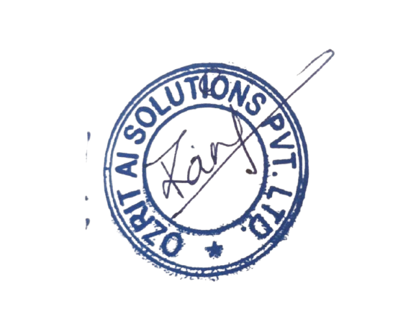

**Rani Kumari**

**HR & Admin Executive**